**REDUCE:**

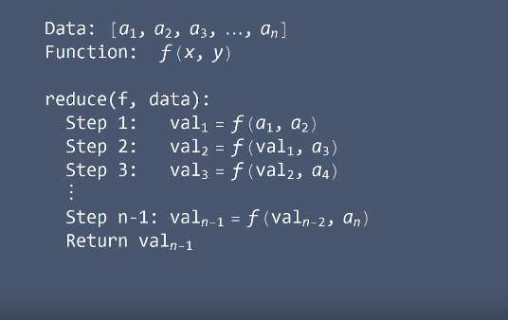

**Advantages of Lists:**

Lists can contain mixed types

Lists can shrink and grow dynamically

**Disadvantages of Lists:**

Lists tend to consume lots of memory

They struggle to work with medium and larger sized datasets

**NUMPY:**

The core data structure in NumPy is the ndarray object, which stands for **N-dimensional array**. An **array** is a collection of values, similar to a list. **N-dimensional** refers to the number of indices needed to select individual values from the object.

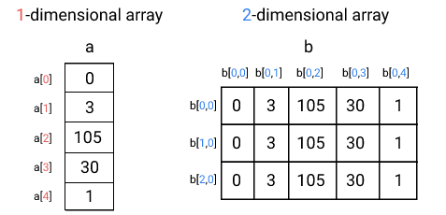

We can read in datasets using the numpy.genfromtxt() function. Our dataset, world_alcohol.csv is a comma separated value dataset. We can specify the delimiter using the delimiter parameter.

Each value in a NumPy array has to have the same data type. NumPy data types are similar to Python data types, but have slight differences. You can find a full list of NumPy data types here. Here are some of the common ones:

* bool: Boolean.
  + Can be True or False.
* int: Integer values.
  + Can be int16, int32, or int64. The suffix 16, 32, or 64indicates the number of bits.
* float: Floating point values.
  + Can be float16, float32, or float64. The suffix 16, 32, or 64 indicates how many numbers after the decimal point the number can have.
* string: String values.
  + Can be string or unicode, which are two different ways a computer can store text.

NumPy will automatically figure out an appropriate data type when reading in data or converting lists to arrays. You can check the data type of a NumPy arrayusing the dtype property.